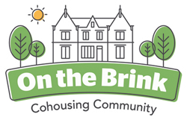
On the Brink Newsletter May 2019
It seems that there are at least four (OK – five), significant On the Brink things happening at the moment:
- We have been living here for exactly one year
- We have got planning permission to build four new living units
- We are launching our new – all singing and dancing - website www.onthebrink.community
- We are putting out a request for supporter loans/ investments to help us build the new phase two houses
- We have a flat for sale – do you know anyone who might like to join us?
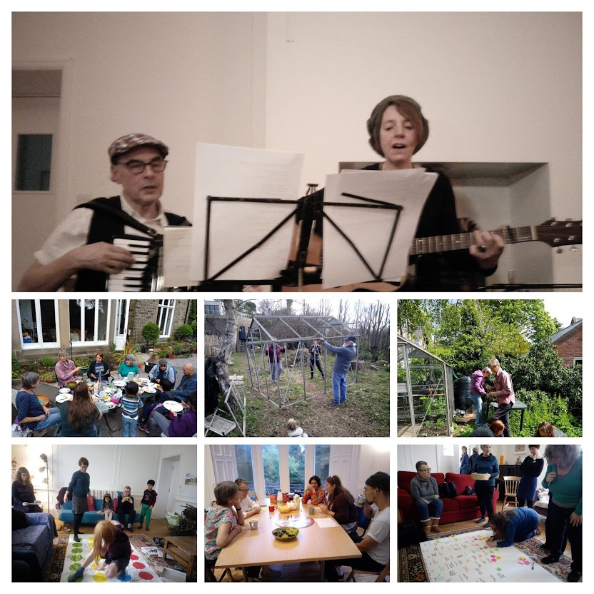
We have just celebrated one year of living in Brincliffe House. Most people moved in on the second of May 2018.
During this time together we have:
- Done a lot of social things together. We have hosted parties and a lovely series of ‘house concerts’. We do regular dancing, yoga, Qigong and eating together.
- We share a lot of ‘things’ like washing machines, tools and equipment.
- Continued to develop the garden with more planting, growing and places for wild life
- Tried to work out ways of living together... in addition to our main business meeting this has involved a series of groups and subgroups. This overview gives an idea of the process work we are doing. If you went to every meeting you would certainly either be barmy – or soon become barmy.
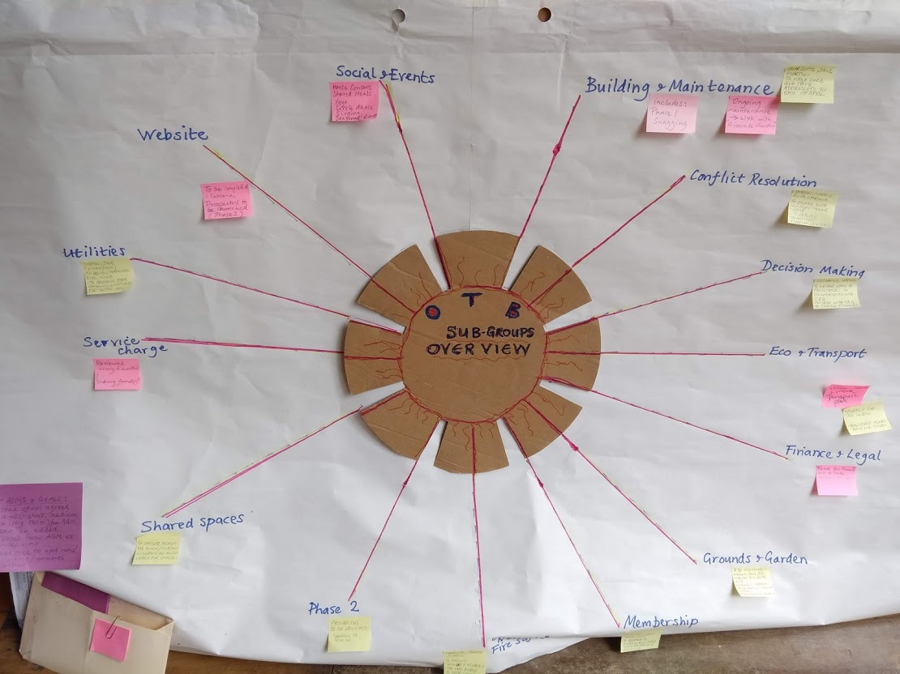

A few days ago Sheffield City Council ‘Place Directorate – City Growth Department – Planning Services’, unanimously approved our application to build four large new living units in the grounds of Brincliffe House. You can follow the details of our application and the official approval documents with one click: https://planningapps.sheffield.gov.uk/online-applications/applicationDetails.do?activeTab=documents&keyVal=PJIXO5NYH1C00
Basically by this time next year, Brincliffe House will have a new extension to the side which will include three new townhouses and there will also be a new Lodge near the Brincliffe Crescent entrance.
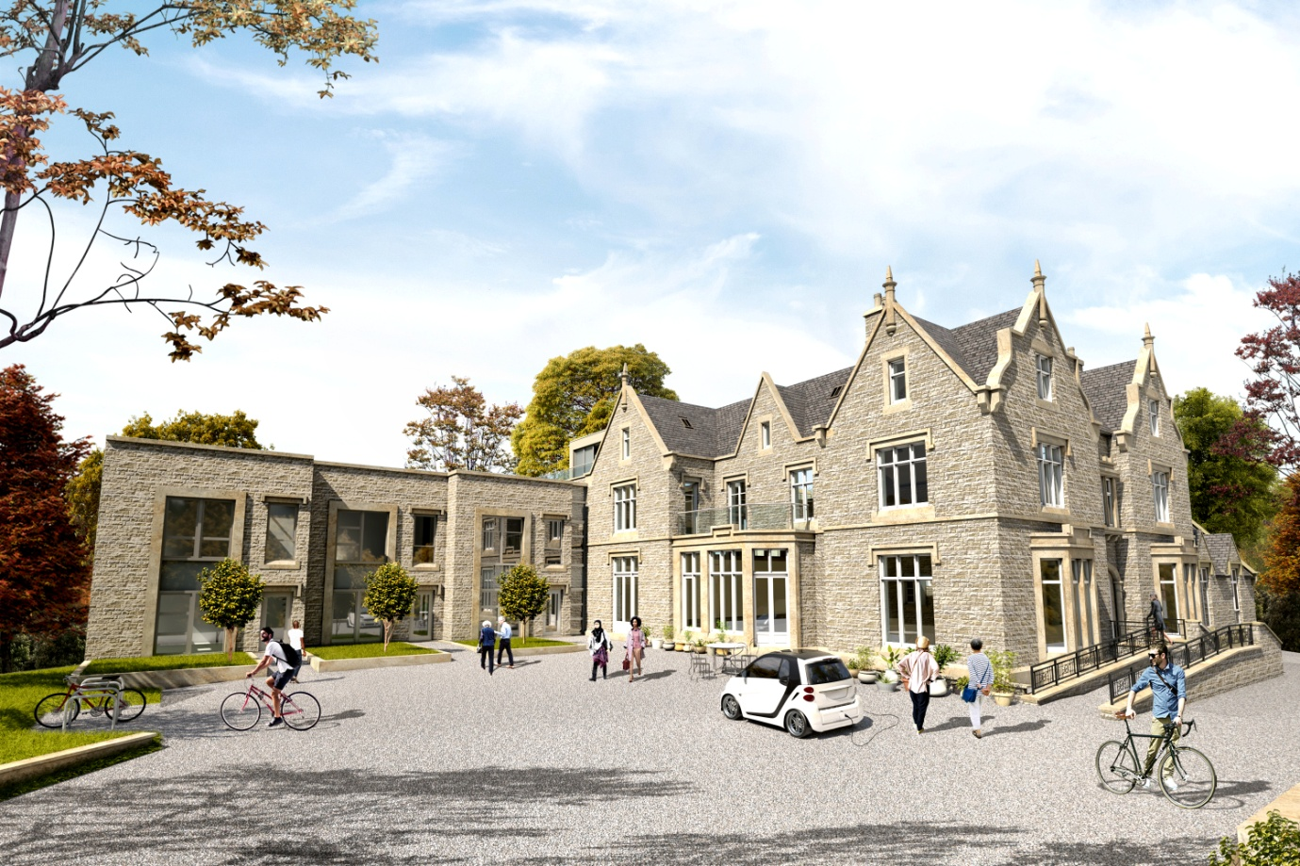
Over the last eight months or so we have been joined by an intern, Melissa Nesbitt, from Sheffield Hallam University. Turns out that she’s a prize-winning graphics student and she has created a lovely new website for us. Thanks to the marvels of modern technology the new website has replaced the old one and can be reached by clicking on: www.onthebrink.community
The website has new tabs for you to explore the life of On the Brink in a bit more detail. If you have a moment perhaps you can let us know what you think of the new look website.
Financial support for our phase two development.
Basically we need to be able to pay the builders for building the new living units. When the building work is finished the new members will pay for their units and we can pay back our investors. Investors will be able to choose the amount of interest that their money earns – up to a maximum of 3% which isn’t bad in these days of low interest rates. Of course there’s no pressure whatever to join this scheme but if you do want to find out more you can click on:
otb_prospectus__2019.pdf
Download File

We can’t resist showing you some pictures of the things going on in the garden. As well as the usual planting and gardening activities we have been given a couple of greenhouses and set up some bee hives ...
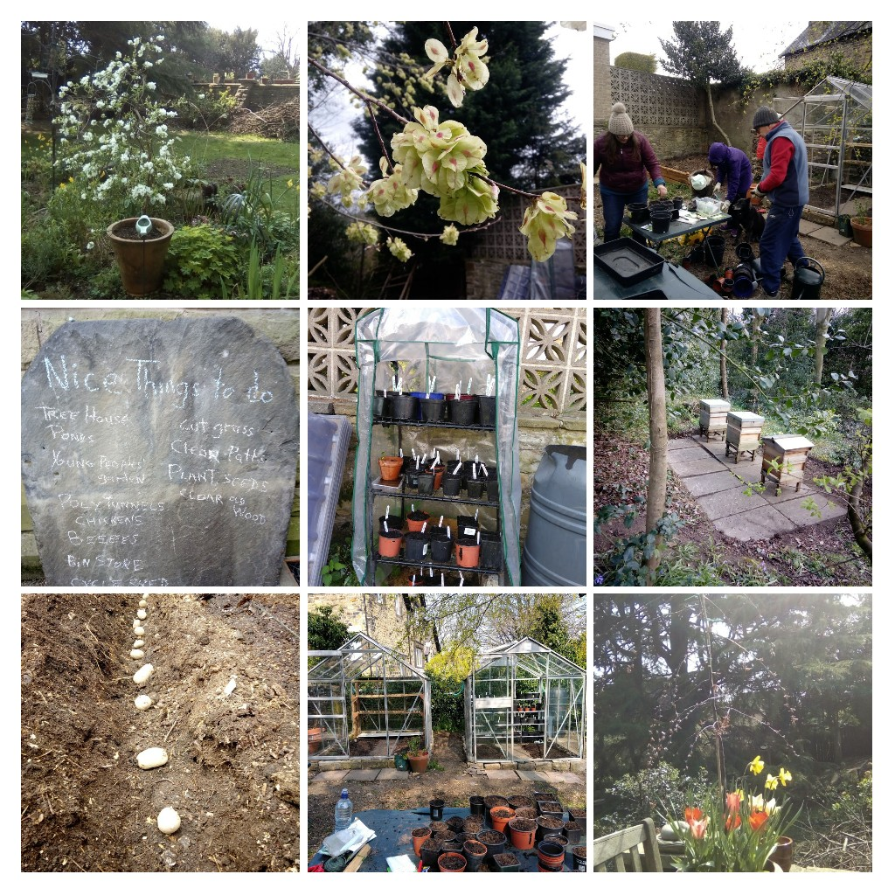

Finally we have a flat for sale. It is a lovely duplex arrangement 66.60 square metres in total. If you know anyone who shares our vision and might like to come and live with us please ask them to contact us on: otbcohousing@gmail.com