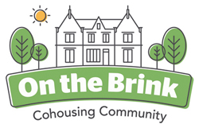

2021 - End of year newsletter

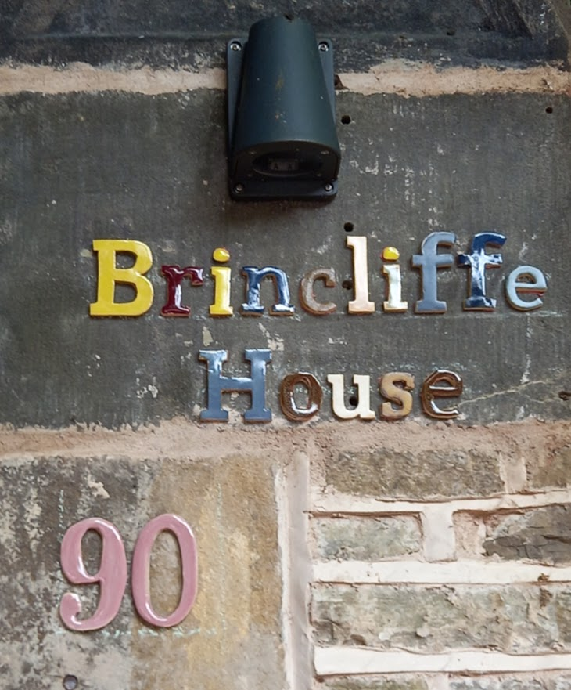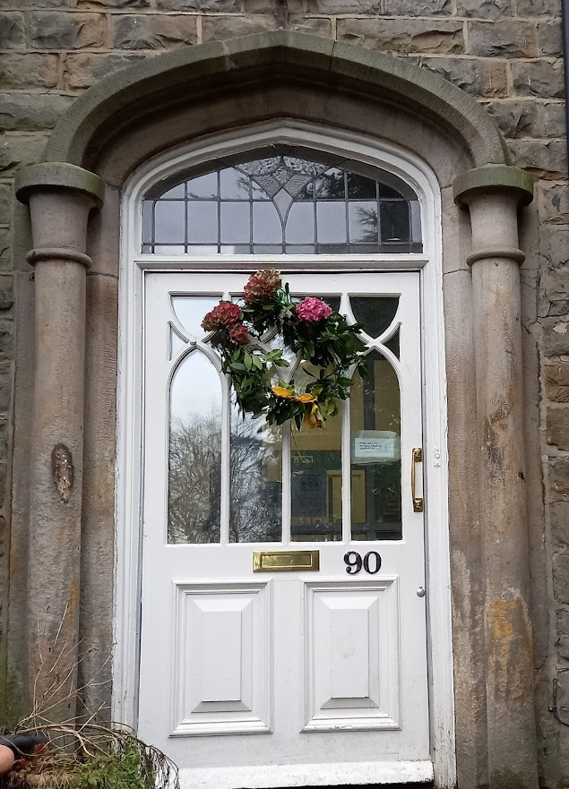

What has been going on at On the Brink over the last year?
The turmoil surrounding the Covid-19 epidemic that has changed so many certainties throughout the world has obviously had a challenging effect on our little community here in Sheffield.
So many of our individual and collective reasons for choosing to take part in this cohousing ‘social experiment’ relate to the ways we interact, celebrate and support each other. For the last 18 months many of these vital features of our collective lives have been disrupted, adapted or simply been postponed. We have done our best to maintain some of the social events that have established themselves as the marker events of our time together. Film night continues most Tuesdays and many of us do eat together every Friday evening, outside whenever that’s possible. We have had pizza parties and birthday parties of course… and our May Day and solstice dressing up noisy parades have become an established tradition.
Every month a gardens and grounds work day happens often including child labour:-
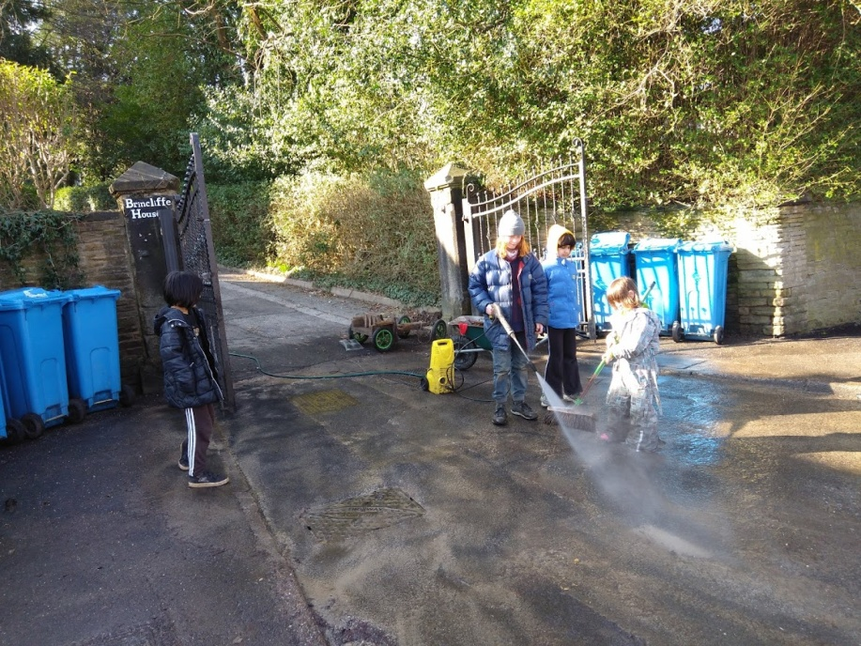
There’s no doubt that the six young people, our ‘Brinklets’, are the beating heart of our community. They are involved in just about every activity and usually find ways of having their say in what goes on here. The pandemic has changed the way that they have to live their lives within the community, at school and in the wider world. Somehow they have continued to be as sociable, creative and as much fun as they possibly can be. We continue to learn from them.
We have resumed some absolutely top class concerts in the open air whenever the Covid restrictions allow. For obvious reasons each of these events is more difficult to organise during the cold, damp months. It feels as though the whole community is like a coiled spring waiting to burst back into full social action when the warmer weather arrives and the pandemic restrictions become less essential. Hopefully social interactions with our neighbours will also be resumed as Spring arrives.
This year there have been comings and goings at On the Brink. At the beginning of the year all the four new phase two houses were finished and occupied. Remember that this was the architect’s vision of the way that our completed development would look:- 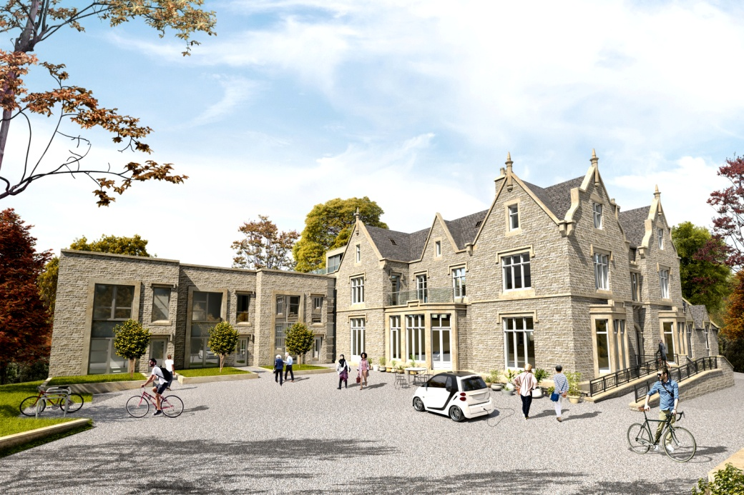
And this is the reality now:- 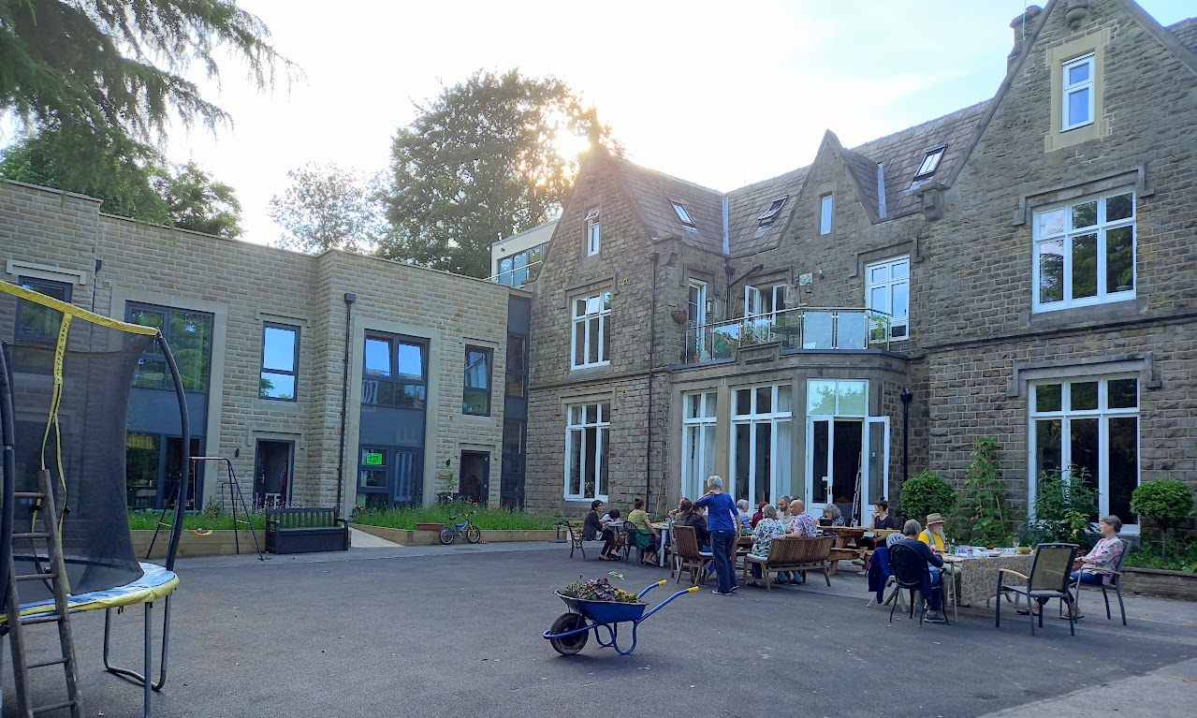
Earlier this year we became a complete community with 20 adult members and 6 children. One member decided to leave in the middle of the year and the second half of the year has been occupied with choosing a replacement member to join us. There’s not been much change in the membership of On the Brink in the last four years and we continue to learn how to manage these complicated, unsettling transitions… Perhaps we aren’t so different from all the other cohousing communities throughout the UK in this respect. We look forward to welcoming our newest member into the community soon.
As well as humans coming and going we are sad to announce that Bobby, the brave old black and grey dog from Flat 1 has died. There can be no replacement for Bobby of course, but we do have a sprightly new dog, Buddy, joining Mambo on the top floor.
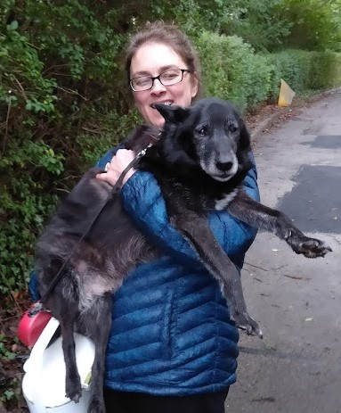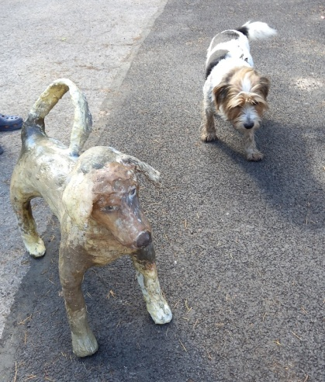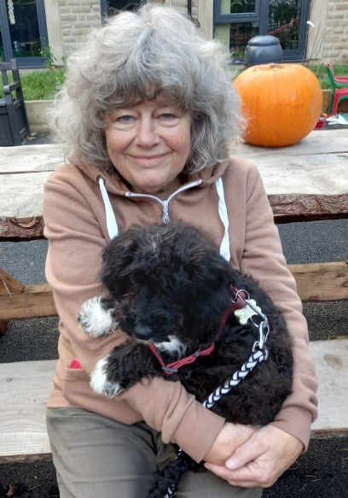

Two cats now live on the ground floor and valiantly attempt to keep the rodents under control throughout the grounds. Only one of the cats ever stays still long enough to be photographed - so this is Elton – twice.
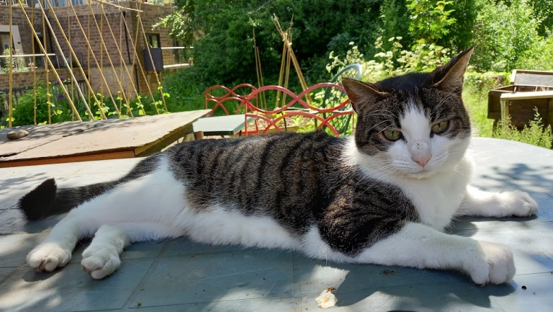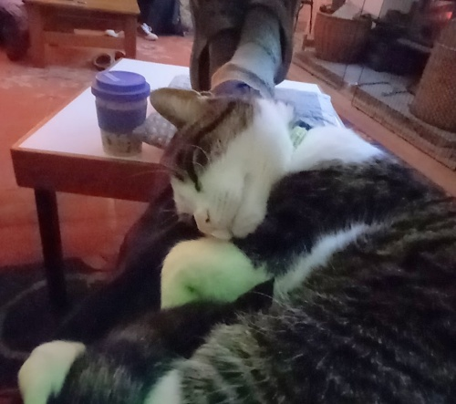
The chickens provide a continual source of interest and companionship and a decent supply of eggs. 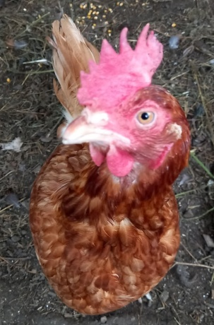 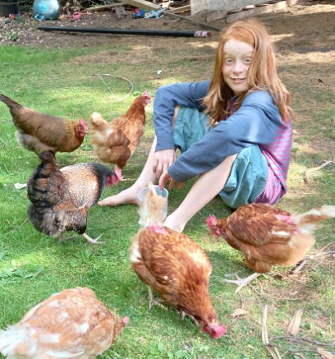 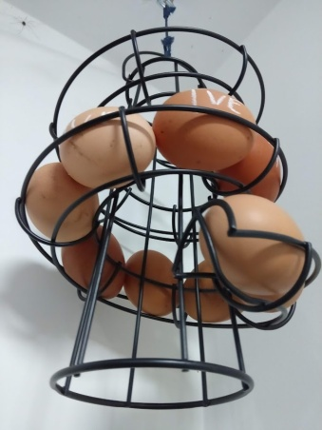
The bees on the roof of the terrace houses seem to be thriving and we anticipate filling more hives and extracting honey next season.
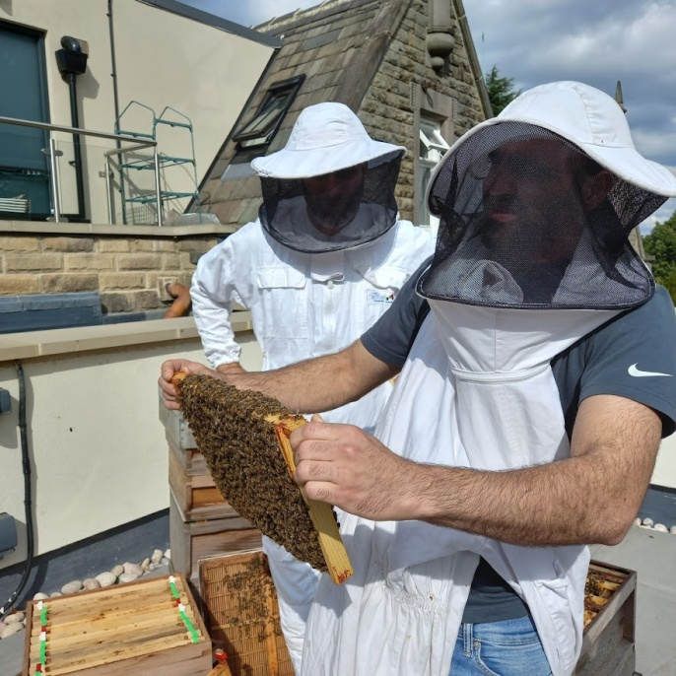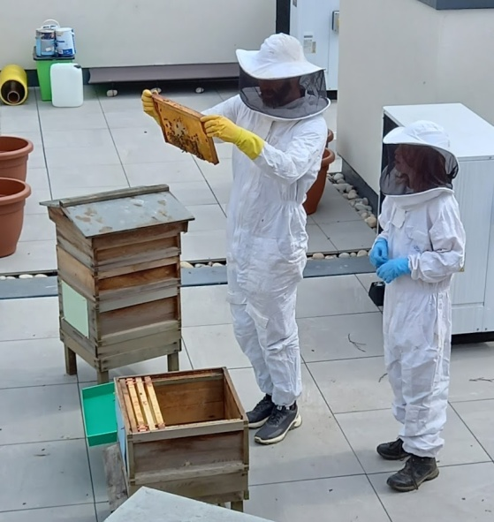
There’s been a big transition in the way that we are trying to organise ourselves. The old guard of company officers – the chair, the secretary and the treasurer of On the Brink Company - have been replaced by new, younger models, and a brand new set of committees, interest groups and decision making structures has been introduced. The hope is that some devolution of decision making will ease the bottlenecks that have been a feature of life ‘On the Brink’ (and probably every other cohousing group since the beginning of time).
Financially we are also entering a new phase. The major building/ development work has been successfully completed and all our external development loans have been paid off. Of course there are still some significant ‘snagging’ issues which need to be sorted out with the building contractor before we pay their final retention sum. Over the last four years we have learnt a lot about refurbishing old houses, building new houses and all that stuff …. and our collective job from now on is to live here alongside each other and continue to develop the community as best we can.
A socially distanced Halloween foray by a seriously scary multigenerational On the Brink gang along Brincliffe Crescent has reinforced our reputation in the neighbourhood as being pretty much bonkers through and through. But a really positive response from all the neighbours was reported. The little free library at the end of the drive has been successful. No vandalism reported and people from the locality take books appropriately and have even been seen to re-stock the shelves from time to time. A second free library is planned for the end of the Osborne Road driveway.
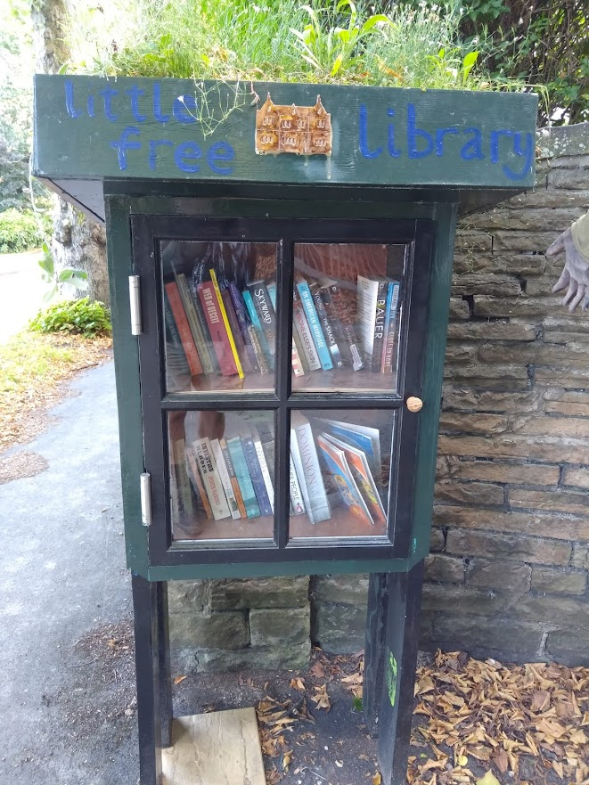

The gardens and grounds continue to delight:-
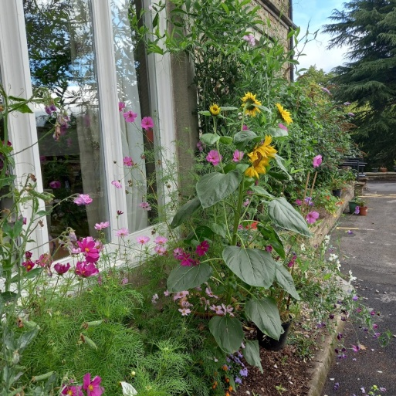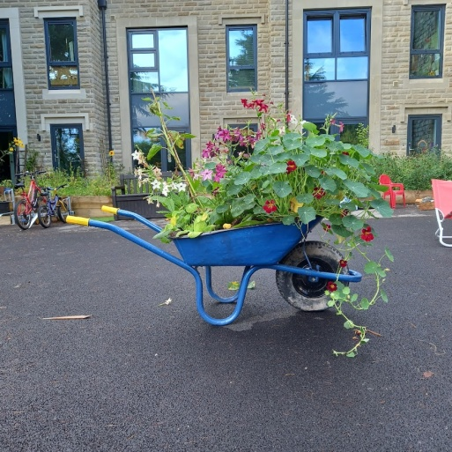
The way that we use the outside spaces is still being discussed and developed and will be a major focus for our community now that the building work has been completed. The allotment area has been super productive this year and the badgers have been successfully reintroduced to their sett at the back of the house.
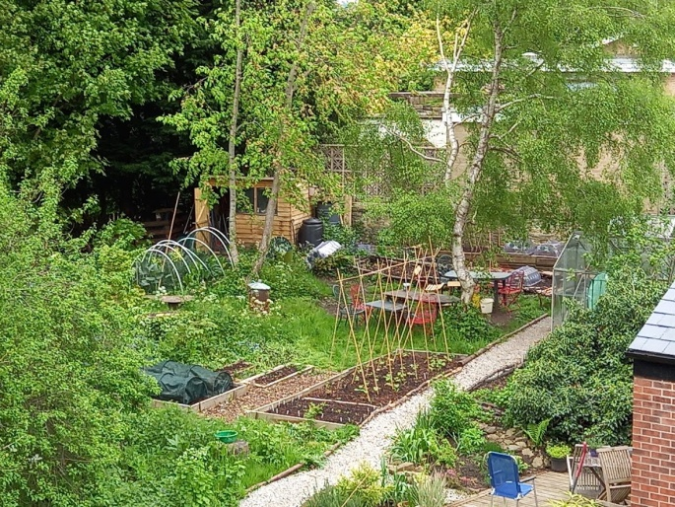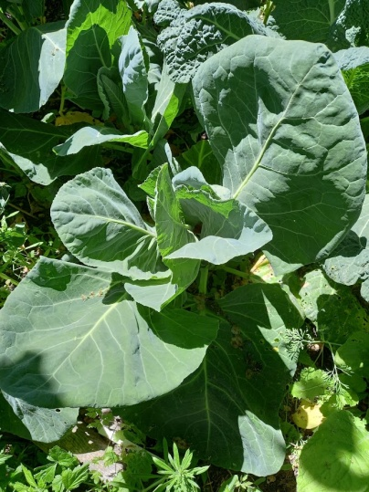

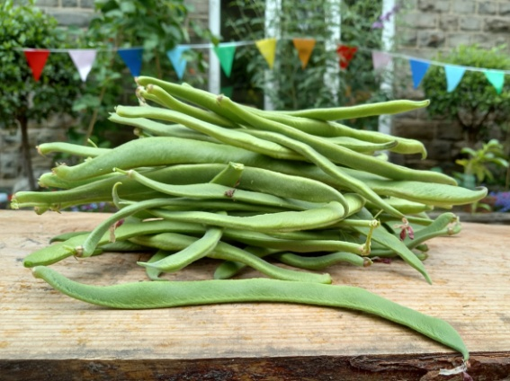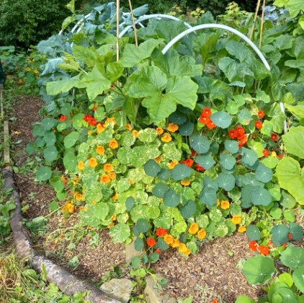

The whole place even looks good in the snow:-
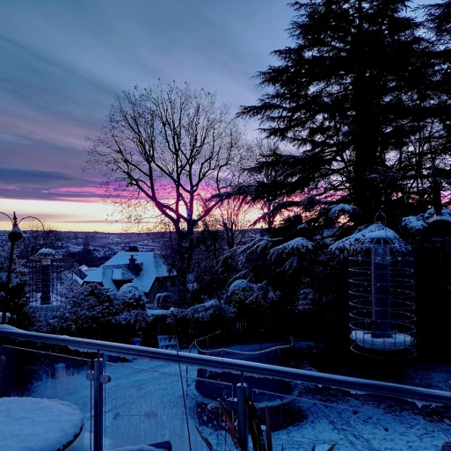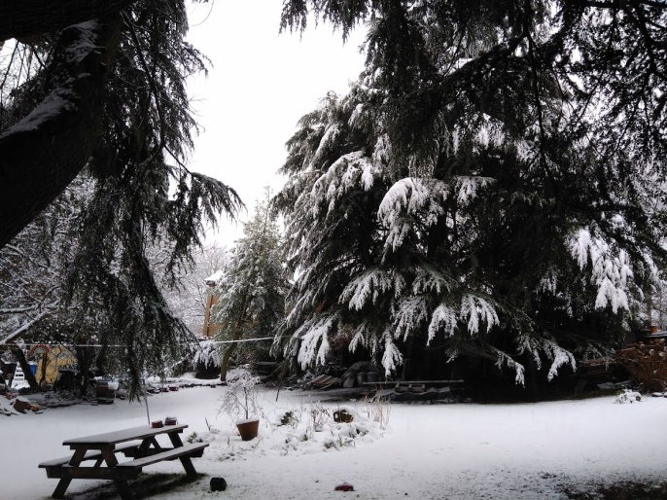
This newsletter is also our opportunity to thank so many people who have made this project possible and for whom we are so grateful. This includes Linda and Oliver who steered us safely through the financial minefields associated with the development process and of course all the external supporters who lent us money for the development phase. We have been enormously fortunate in the team of professionals who have supported and advised us wisely at every step of the way. Our solicitors, architects, banker, quantity surveyor and a full range of specialist consultants have brought us safely to this stage in the development of our community. Thank you.
Let us all hope that the year 2022 brings more peace and certainty as we continue to grow and develop as a community. We send our love to all of you who have supported us this year.

Here are some bonus mini-videos of Brinkie life to watch if you have a moment:

OTB Open Air Concerts:
OTB Concert Rheingans sisters - YouTube
OTB concert Indian Raga Trio - YouTube
Goings on in the grounds of OTB:
DRR 0117 - YouTube
DRR 0114 - YouTube

