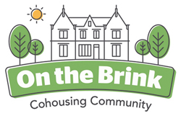 **On the Brink Newsletter June 2020**

There’s no escaping the fact that OTB is facing two major challenges at the moment. There’s the building work on our four new houses that’s going on as we speak. We have planned and budgeted in great detail for this phase in our development - but who could have imagined that we would have to do this work at a time of major global disruption caused by a teeny weenie virus?

I think (fingers crossed), that we are coping extremely well with both these additional elements to our life ‘On the Brink’. Everything is different, but somehow everything is the same. We have become a robust, supportive and resilient community and many of the things we prided ourselves on before the pandemic continue - albeit in different, imaginative forms. There’s been a lot of work making sure that we remain as safe as we can be – while at the same time not stifling the social and creative elements that give the community its specific, rather joyous character. Of course within the community there’s a spectrum of individual responses to the very real threats that we all face and life isn’t easy for all of us all the time. We remain distant from each other physically - but very close to each other socially and emotionally. If you had to choose to live through a global pandemic where would you be better placed than being surrounded by such a great gang?

Sure, a great number of our business interactions now take place electronically. Perhaps the Zoom meetings focus our minds on the work we have to do? The building work was interrupted for five weeks, but is now going ahead at full steam. Our new building contractor, O&P Construction <https://www.opconstruction.co.uk/>) seem to be really good communicators and are intent on building our four new houses to a high standard.

Here’s the latest view of the three terraced houses being constructed in front of our very eyes:

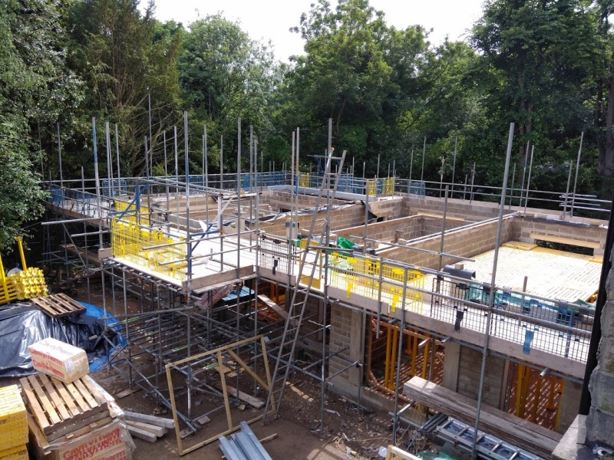

And the new Lodge House (now called Brincliffe Lodge), is rising at the bottom of the Brincliffe Crescent driveway.

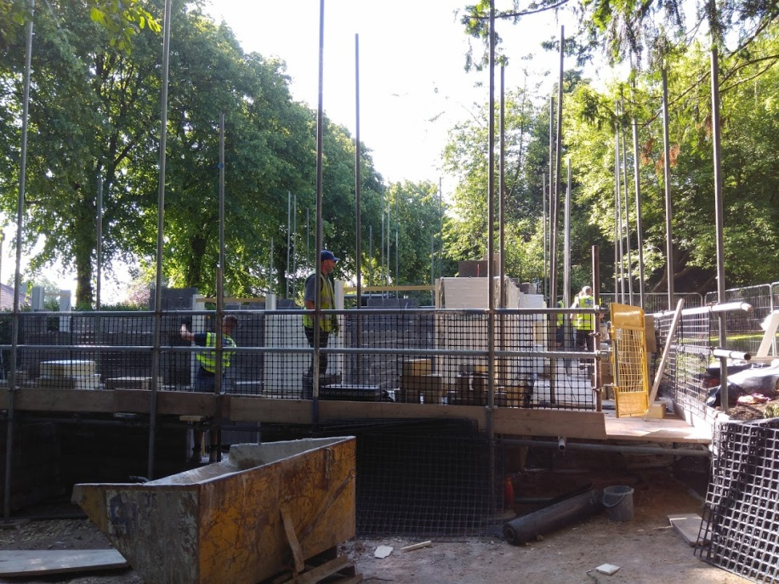

**Life in the Community Continues**

I hope that we have always tried to be outward looking as a community - as well as taking care of ourselves and each other. OTB members who are part of communities in the wider world – choirs, protest and campaigning groups and good, socially aware works generally are adapting and continuing to contribute to support and campaign for those vital issues. As a community we joined in each of the Thursday evening Brincliffe Crescent front line workers clapping events – albeit recognising that most of the front line workers would prefer decent pay and conditions in the future. Those of you who know us wouldn’t expect us not to show support for Black Lives Matter

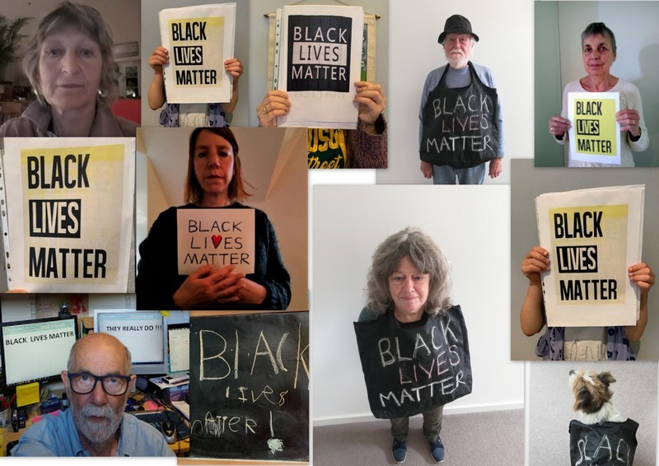

So there’s lots of remedial fence painting, wall building, log store constructing and a host of other DIY work being done in the grounds and gardens. Here’s a flavour of some of the recent work:

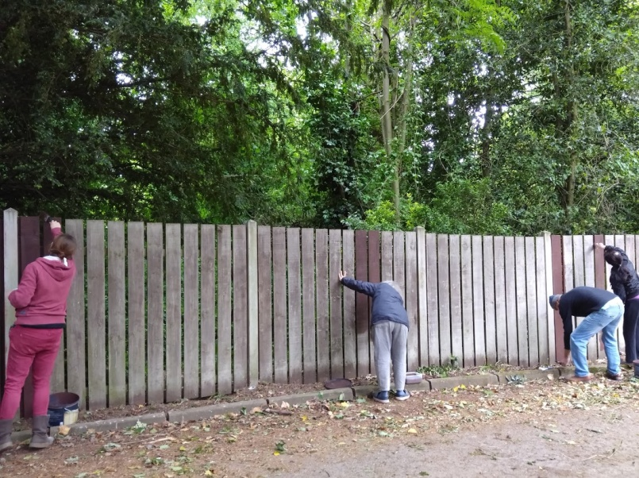 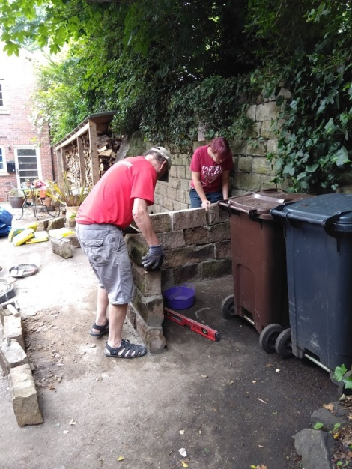

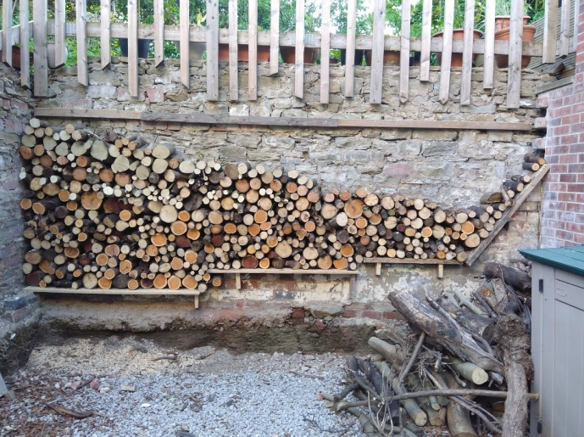 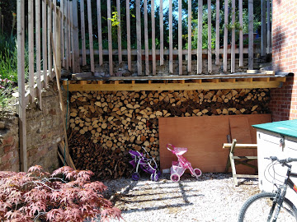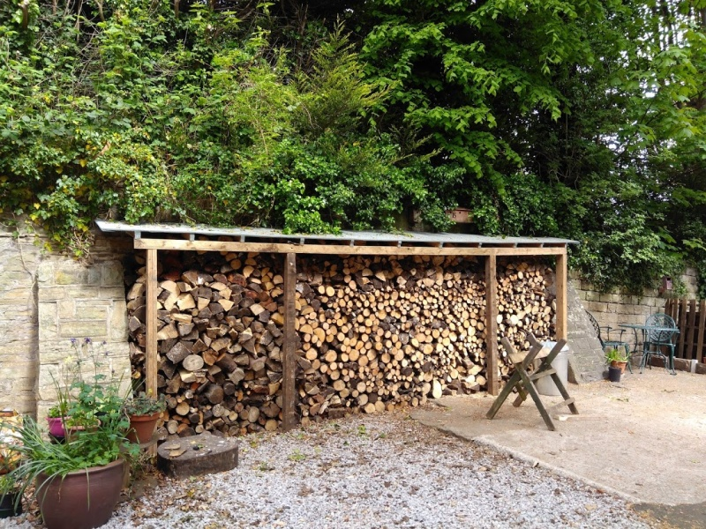

Our next OTB newsletter will hopefully feature more news and photos of the amazing growing in the allotment garden and various wildlife updates...

The OTB community is continuing those things we do to sustain and support ourselves and each other. On a practical level during this time of Covid-19 there’s a lot of supermarket shopping being done by those who are able to get out. While two of the community had the virus itself they were supported wiith amazing understanding, patience and creativity.

Our Harmony, Wellbeing and Communication group arranged a ‘Heart Circle so we can share our feelings and support each other in a non judgemental (electronic) space.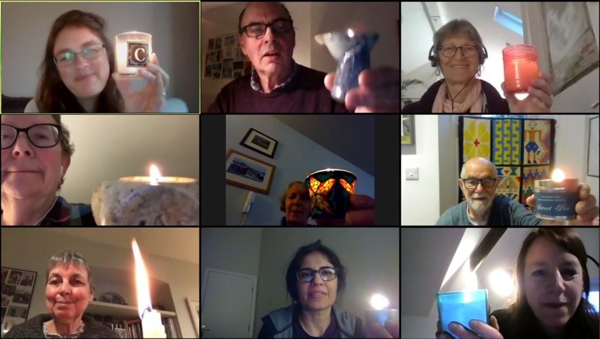

And of course there’s celebrations to be had – Tanith’s super level graduation, various birthdays, May Day (now a firm tradition) and re-instatement of Friday evening meals together.

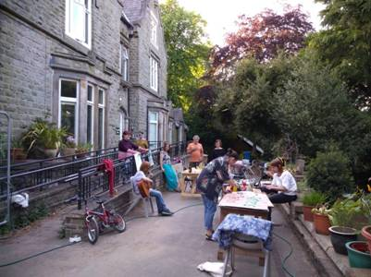 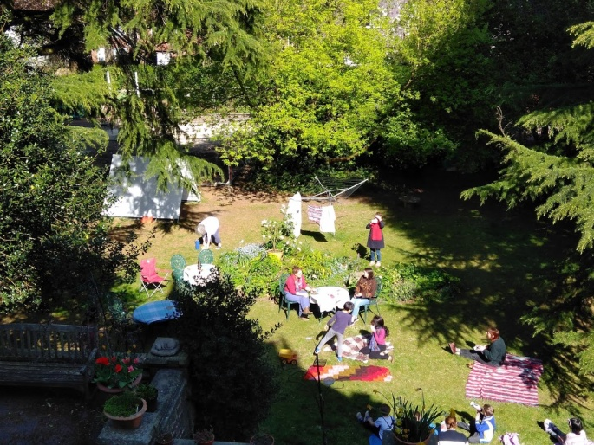

Sadly Mary Toon (Kate’s mother), our oldest and possibly most fervent supporter died aged 97. She was a regular visitor here and always a delight. We celebrated her life in a way we hope she would have appreciated.

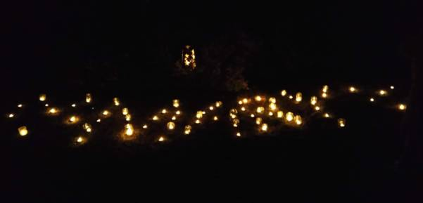 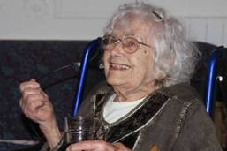

**The chickens continue to give delight – and eggs.**

Unfortunately Miracle – our feisty, Geordie, Rhode Island Red with a black tail and plenty of attitude died after a long illness. Here she is with Willem who (along with the other young people on site) gave her the best quality of life possible.

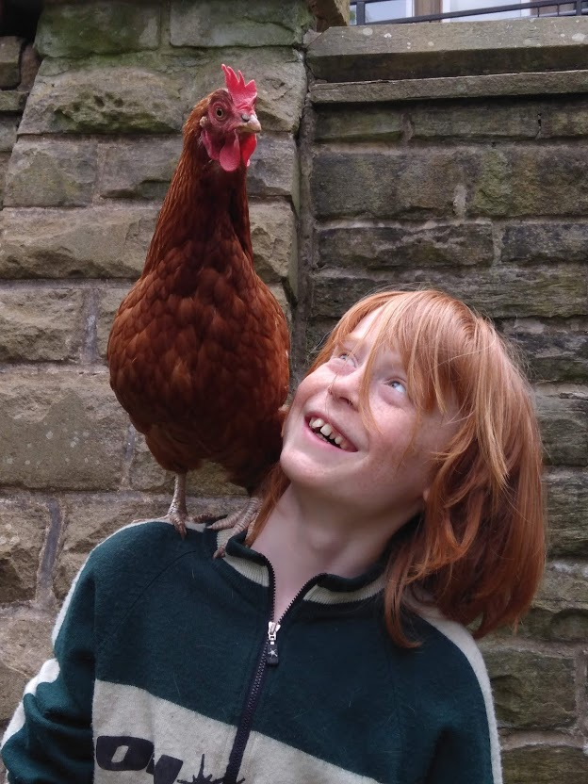 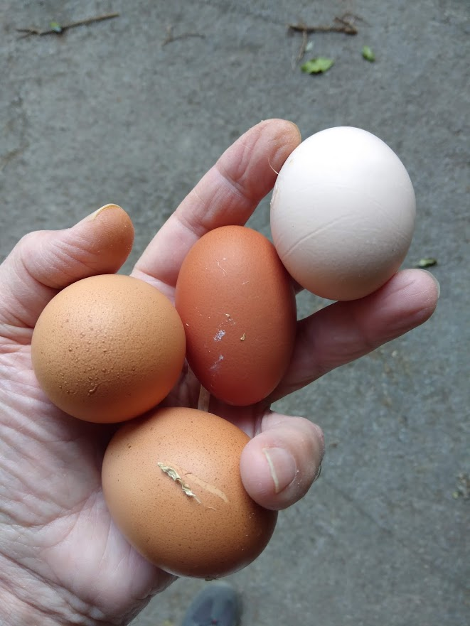

No OTB Newsletter should ever pass without our enormous thanks to those people – our friends and supporters – who have continued to be our friends and support us. Goodness we could not do any of these activities –or even be in existence - without you all ... and indeed what would be the point? So please keep in touch. If you want you can keep an eye on our website: [www.onthebrink/community](http://www.onthebrink/community) or via Facebook @otbcohouse . Our e-mail address remains: [otbcohousing@gmail.com](mailto:otbcohousing@gmail.com)

We look forward to being more immediately social with you all at the first chance of normal post-Covid services being resumed.

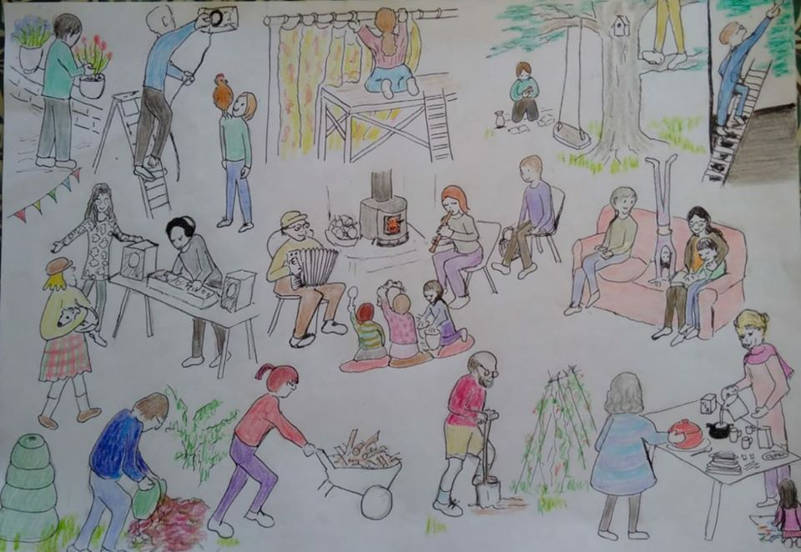

Here we all are...

Tom Heller on behalf of On the Brink Cohousing Community 26/06/2020