Perhaps it’s about time that I wrote to you about our news and particularly about our move into a cohousing community called ‘On the Brink’ in Nether Edge, Sheffield. Well we have moved into Brincliffe House. There are twelve magnificent flats now inhabited by seventeen of us ‘Brinkies’. Mostly we just wander round wondering how we came to live in such a great place with a lovely gang of people. It does seem quite an achievement and a great many of the things we set out to do are on the way to being sorted. As well as the lovely places in which we have the privilege to live we have managed to become a multi-generational community with our ages ranging from 4 to 72 years old (that’s me).
We have started to do some gardening and the first crop of beans, salad leaves, kale, chard and courgettes are already being harvested. Where builders’ rubble once was the only feature there are now flowers, pots growing all sorts, and multiple compost bins. We are doing our best to recycle what we can, plan our journeys by public transport wherever possible and our first set of solar panels is now functioning.
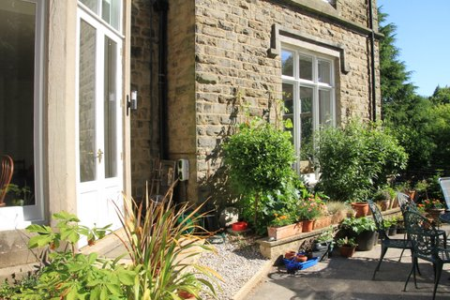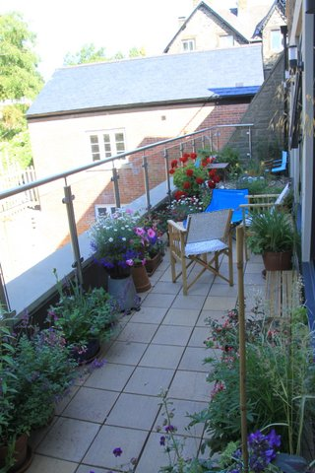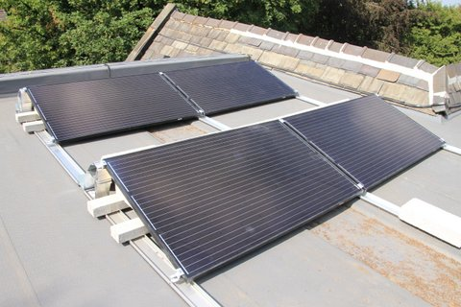
We have been trying to restore some of the original features to Brincliffe House. The tiles on the ground floor, which for decades were covered by NHS carpet, have now been revealed and cleaned.
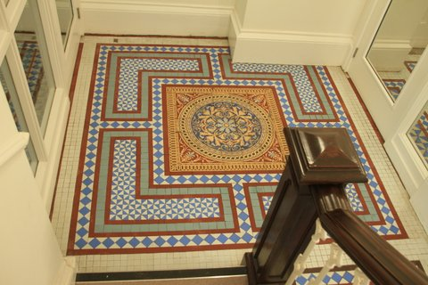

Several of us have been learning how to restore some of the stained glass windows that the NHS had removed, but thankfully stored in the attic. It has been great fun to learn how to replace the broken glass and now we are putting some at least of them back into the windows for which they were originally designed. This one (pictured), is nearly ready to be reinstated somewhere in the house.
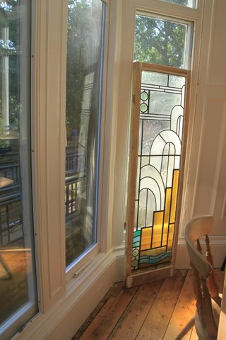
Lisa and I have also made some new stained glass images for the two front doors (!) to our flat, number seven.
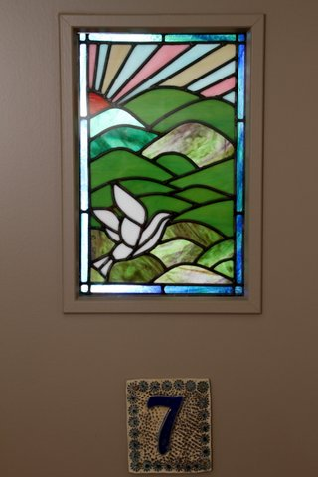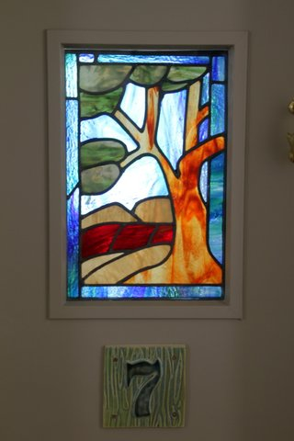

Of course the building work isn’t entirely complete and there have been teething problems. There’s quite a list of ‘snagging’ items that are in the process of being sorted. And hey! It turns out that we don’t all agree about everything. Well that’s a surprise, who would have thought that filling a place with such a gang of lively, strong minded individuals wouldn’t all be plain sailing? But it turns out that ways forward and resolution can be found – as long as there are enough meetings. And this is the secret formula [one solution = 7.46 recurring, meetings]. Here’s pictures of a planning meeting:
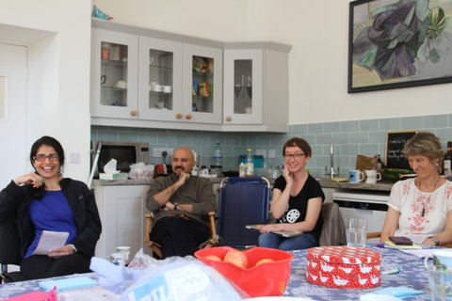
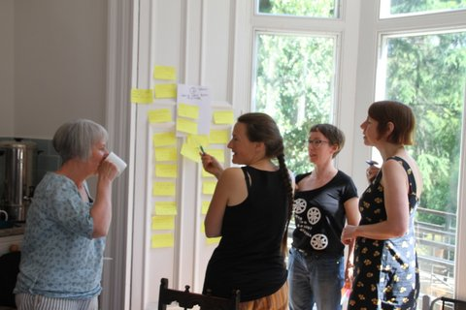
More importantly it seems that we have become good at being social with the neighbours and with each other. Big birthday parties have been held for Jo’s fortieth and for Lisa’s seventieth. We have had a couple of ‘open days’ for the immediate neighbours and seem to have been generally welcomed to the neighborhood. Apart from the owls, the parties and the sounds of children playing in the garden it’s a quiet place to live.
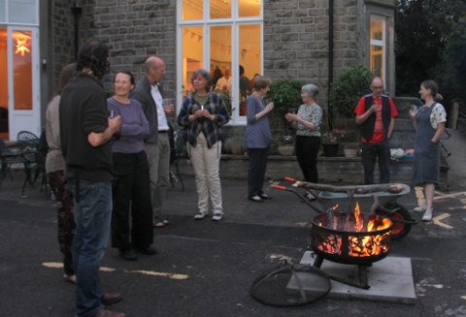

Here’s a picture of our first shared meal. Fridays will be shared meals night.
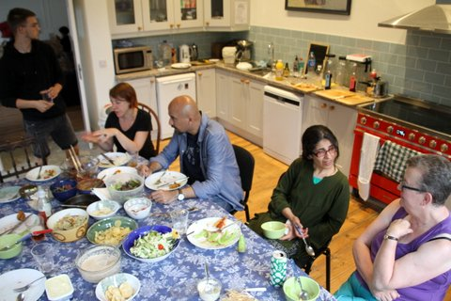

We are now planning as fast as we can for ‘phase two’. We are hatching detailed plans for four new-build living spaces – three as an extension to the house itself and a lodge at the bottom of the garden. These plans will become a ‘planning application’ in a couple of weeks time and so the process will start again to develop the community to its full size.
That’s enough for now. There are so many people to thank for their support in getting this project underway - and that includes teams of professional helpers, architects and banks and building contractors as well as our family and friends - without all of their support none of this could have happened.
Love Tom x
Flat 7, Brincliffe House,
90, Osborne Road,
Sheffield
S11 9BB
https://www.facebook.com/otbcohouse/
www.onthebrink.community

